AUTHOR PAPER TEMPLATE
Complete Guide with Dummy Data, Tables, Graphs and Figure Examples
Purpose of this template
This document shows authors exactly how to structure a paper or extended abstract for online submission. It includes dummy title-page details, a sample structured abstract, sample methodology text, sample findings, tables, graphs, a conceptual figure, example captions, references, and a final submission checklist.

How authors should use this guide
- Read the completed sample to understand the expected writing style and structure.
- Replace the dummy title, author details, abstract, data, graphs, findings and references with your actual paper content.
- Keep the required headings for the structured abstract: Purpose, Methodology/approach, Findings, Conclusion and recommendations, and Originality/value of contribution.
- Ensure the abstract does not exceed 350 words and include 4 to 5 keywords.
- Delete all guidance notes and dummy examples before uploading the final file to the submission site.

Sample title-page information
Item | Details
Paper title | Artificial Intelligence Adoption in Higher Education: Evidence from a Public University Context
Author name(s) | Dr Thandi Banda; Mr Joseph Phiri; Ms Memory Chirwa
Qualification(s) | PhD; MSc; MA
Affiliation(s) | Department of ICT, Example University, Malawi; School of Education, Example University, Malawi
Corresponding author email | tbanda@exampleuniversity.ac.mw
Thematic area | Human capital development
Subtopic | Technology in education
Paper type | Research paper
Version 2.0 | Site-ready author template and worked example

1. Formatting requirements
Element | Requirement
Page size | A4
Margins | Approximately 2.0 cm / 0.8 inches on all sides
Font | Times New Roman
Body text | 11-point, 1.15 line spacing, left aligned or justified where appropriate
Title | 18-point or larger, bold, centred
Main headings | 14-point, bold
Subheadings | 12-point, bold
Tables | Number consecutively. Put the title above the table.
Figures/graphs | Number consecutively. Put the caption below the figure.
References | Use one referencing style consistently. APA 7th edition is recommended unless another style is specified.
Important for submission site upload
The site can host this Word file as the official template. Authors may download it, replace the dummy content, and upload the completed paper or abstract through the online submission form.

2. Worked example paper

Artificial Intelligence Adoption in Higher Education: Evidence from a Public University Context
Thandi Banda, PhD; Mr Joseph Phiri, MSc; Ms Memory Chirwa, MA
Department of ICT, Example University, Malawi | School of Education, Example University, Malawi | tbanda@exampleuniversity.ac.mw

3. Structured abstract
Abstract requirement
Maximum 350 words. This sample is intentionally concise and shows the required headings. Replace all sample text with the actual abstract.The full paper should not exceed 12 Pages

Purpose
This paper examines the readiness of academic staff and students to adopt artificial intelligence tools for teaching, assessment, research support and learner engagement in a public university context.

Methodology/approach
A mixed-methods design was used. Survey data were collected from 180 respondents, comprising lecturers, students, administrators and ICT support staff. Key informant interviews were conducted with 12 staff members involved in teaching, quality assurance and educational technology support. Quantitative data were analysed using descriptive statistics, while qualitative responses were thematically coded.

Findings
The dummy findings suggest high awareness of AI tools among academic staff but uneven levels of practical use. Adoption was associated with digital skills, availability of institutional guidance, perceived usefulness, ethical confidence and technical support. The sample data also show that students were more likely to use AI for brainstorming and revision, while lecturers used AI for assessment design, content preparation and research assistance.

Conclusion and recommendations
The paper concludes that AI adoption in higher education requires more than access to tools. Institutions should develop clear AI-use policies, strengthen staff and student capacity, promote ethical use, and integrate AI literacy into teaching and learning support systems.

Originality/value of contribution
The paper contributes a practical readiness framework that links institutional policy, digital skills, responsible AI use and learning outcomes in a developing higher education context.

Keywords
Artificial intelligence; higher education; digital skills; responsible innovation; technology in education

Paper type
Research paper

4. Introduction
Artificial intelligence is increasingly influencing teaching, learning, research and institutional administration. In higher education, AI tools can support lesson preparation, assessment design, academic writing, student feedback, learning analytics and administrative decision-making. However, the value of AI depends on readiness factors such as digital skills, policy guidance, infrastructure, ethical awareness and sustained technical support.
This worked example is aligned to the thematic area Human capital development and the subtopic Technology in education. It demonstrates how authors may connect a research problem to a conference theme while presenting evidence in a clear and structured manner.
Writing guide
In your own paper, state the problem, explain why it matters, locate it within one conference theme/subtopic, and end the introduction with the objective or research question.

Objective of the sample paper
The objective of this sample paper is to assess institutional readiness for responsible AI adoption in teaching and learning, using dummy data for illustration.

5. Literature review / contextual background
The literature on educational technology suggests that successful innovation depends on the interaction between people, processes, policy and infrastructure. AI adoption also raises questions about academic integrity, privacy, fairness, digital exclusion and the changing role of educators. In developing contexts, the debate must also consider bandwidth, device access, institutional support and the need for contextually relevant AI policies.
For this sample, the review is framed around four readiness dimensions: institutional readiness, digital skills, responsible AI use, and learning engagement. These dimensions are later presented in the conceptual framework.

6. Methodology / approach
This dummy study uses a mixed-methods design to demonstrate the expected level of detail. A structured questionnaire was administered to 180 respondents selected from academic staff, students, administrators and ICT support staff. The questionnaire collected information on AI awareness, frequency of use, perceived benefits, perceived risks and support needs. Twelve key informant interviews were also conducted to obtain deeper insight into policy and implementation issues.
Quantitative data were analysed using frequencies and percentages. Qualitative data were coded into themes, including policy readiness, training needs, ethical concerns, infrastructure, and pedagogical transformation. Since this is a template, the data below are illustrative only and must be replaced with actual study data before submission.

Table 1: Dummy respondent profile
Respondent group | Number | Percentage | Main role in the study
Lecturers | 68 | 38% | Teaching, assessment and research support
Students | 79 | 44% | Learning, revision and academic support
Administrators | 18 | 10% | Policy, quality assurance and coordination
ICT support staff | 15 | 8% | Infrastructure, systems and user support
Total | 180 | 100% | All respondents
Note: The figures in this table are dummy data for demonstration. Replace them with real study results.
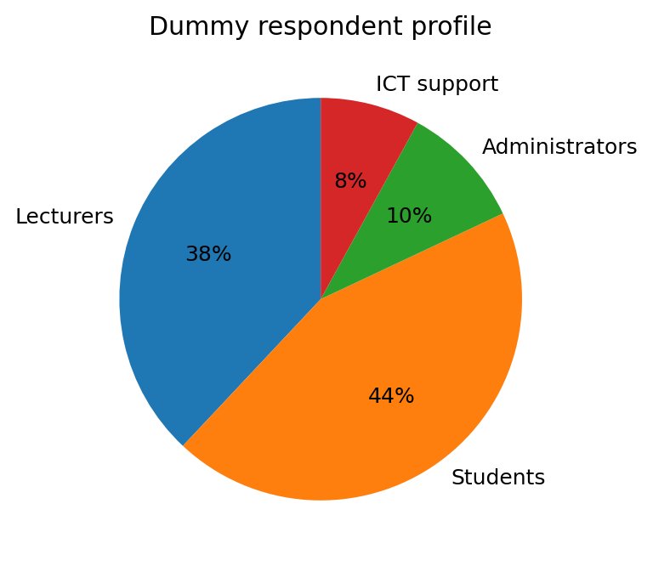
Figure 1: Dummy respondent profile by category

7. Findings / results
This section illustrates how findings may be presented using short explanatory text, tables, graphs and captions. Each table or figure should be introduced before it appears and briefly interpreted after it appears.

7.1 Awareness and use of AI tools
The dummy trend data indicate that awareness of AI tools increased from 32% in 2022 to 83% in 2026. Regular academic use also increased, although it remained lower than awareness across the period. This suggests that awareness alone does not automatically translate into meaningful adoption.
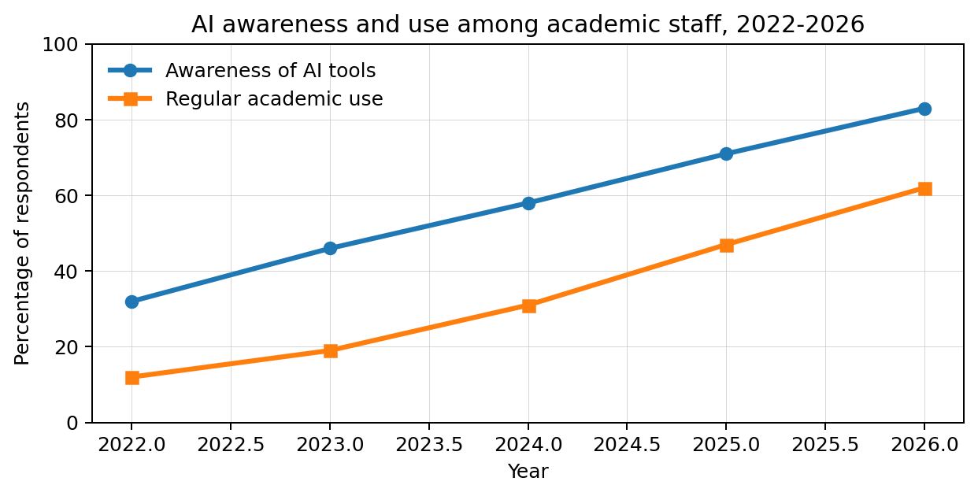
Figure 2: Dummy trend in AI awareness and regular academic use, 2022-2026

7.2 Factors influencing adoption

Table 2: Dummy factors influencing AI adoption
Factor | Agree (%) | Interpretation | Suggested action
Digital skills | 76 | Respondents need practical AI-use skills. | Provide hands-on training.
Policy guidance | 69 | Users want clarity on ethical and acceptable use. | Develop institutional AI guidelines.
Infrastructure | 58 | Access and connectivity still affect adoption. | Improve access, devices and support.
Academic integrity concerns | 72 | Assessment redesign is required. | Use authentic and process-based assessment.
Technical support | 64 | Sustained help is needed after training. | Create helpdesk and user support materials.
Note: Table 2 shows how authors can combine numeric results with interpretation and recommendations.

7.3 Subtopic distribution example
A conference paper may also use graphs to compare categories. Figure 3 illustrates how abstract distribution by subtopic may be presented in a conference management report or meta-analysis paper.
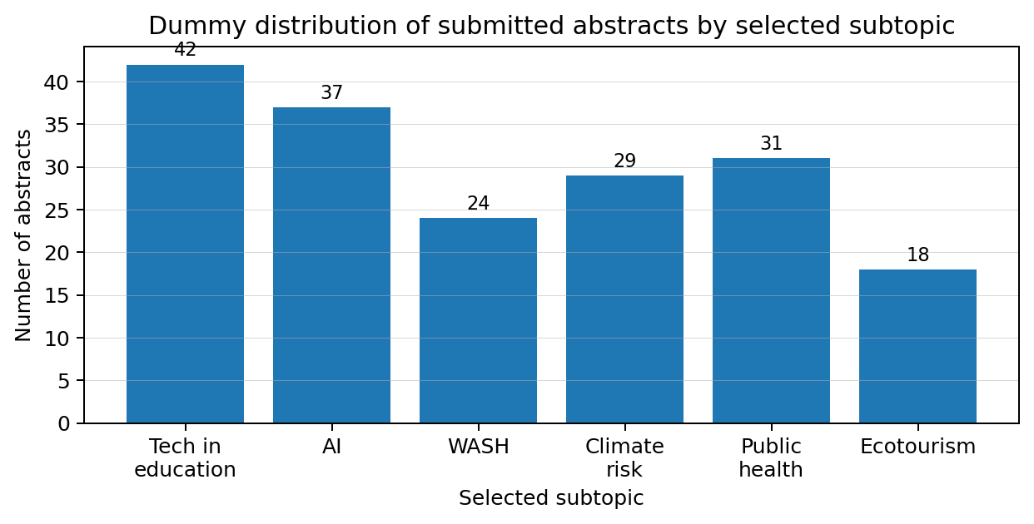
Figure 3: Dummy distribution of submitted abstracts by selected subtopic

8. Conceptual framework or model
Where appropriate, authors may include a conceptual framework, process model, system architecture, intervention model or theory of change. The diagram should be simple, readable and directly linked to the argument of the paper.
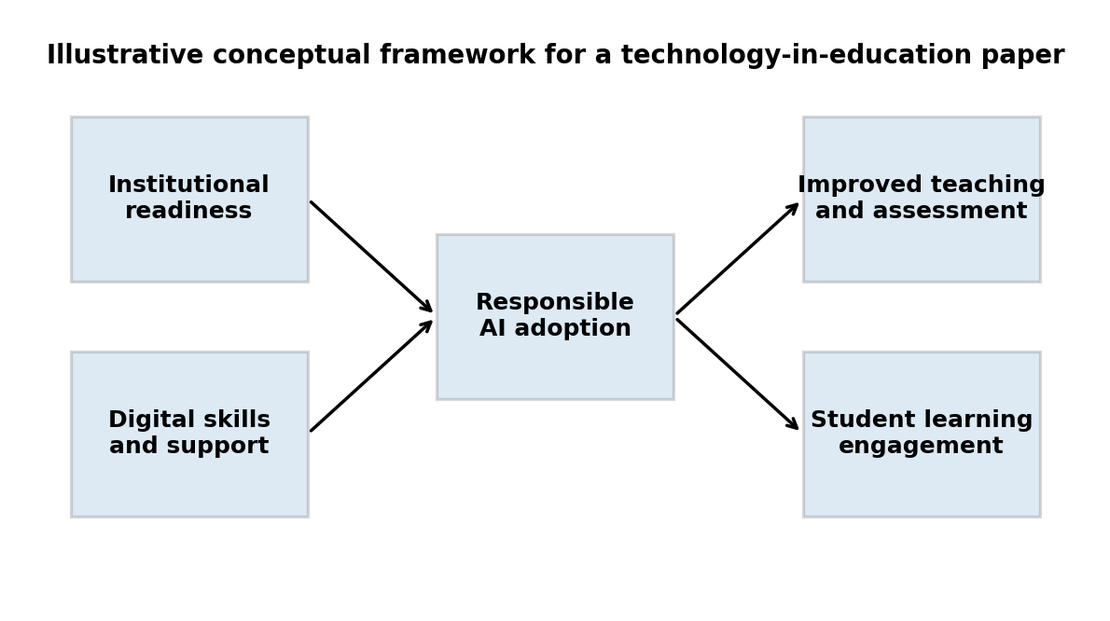
Figure 4: Illustrative conceptual framework linking readiness factors to responsible AI adoption
Figure guidance
Do not insert graphs without explanation. Introduce each figure before it appears, label it clearly, and explain the key message after the figure. Make sure all axes, legends and captions are readable.

9. Discussion
The dummy results suggest that institutional readiness is multidimensional. While awareness and interest in AI tools may increase quickly, responsible adoption requires policy clarity, practical skills, ethical guidance, infrastructure and continuous support. These findings are consistent with the broader view that educational technology transformation is not only a technical change but also an institutional and pedagogical process.
The worked example also demonstrates that discussion should not simply repeat findings. It should interpret what the results mean, connect them to existing literature or practice, and explain the implications for policy, implementation or future research.

10. Conclusion and recommendations
This sample paper concludes that AI adoption in higher education can improve teaching and learning when it is guided by responsible institutional practice. However, adoption should be supported by clear policy, training, infrastructure and academic integrity safeguards.

Recommendations
- Develop institutional AI-use guidelines for teaching, learning, research and assessment.
- Train lecturers and students on practical, ethical and discipline-specific AI use.
- Redesign assessments to emphasise authenticity, process, reflection and application.
- Strengthen ICT support structures for AI-enabled learning environments.
- Conduct further research using larger datasets and discipline-specific case studies.

11. Originality/value of contribution
The originality of this example lies in its integrated readiness framework, which connects institutional policy, digital skills, responsible AI use and learning engagement. In an actual paper, authors should clearly state what is new, useful, contextually important or practically valuable about their contribution.

12. Acknowledgements
The authors acknowledge Example University for supporting the dummy study used for demonstration in this template. In a real paper, include funders, collaborators or participating institutions only where appropriate.

13. References
Referencing guide
Use one referencing style consistently. The following examples are dummy references for layout demonstration only. Replace them with actual sources used in your paper.
- Banda, T., Phiri, J., & Chirwa, M. (2026). Artificial intelligence adoption in higher education: A readiness perspective. Journal of Digital Learning and Innovation, 12(2), 45-61.
- Creswell, J. W., & Creswell, J. D. (2023). Research design: Qualitative, quantitative, and mixed methods approaches (6th ed.). SAGE.
- Ministry of Education. (2025). Digital education transformation strategy. Government Printer.
- World Health Organization. (2024). Digital health implementation guidance. WHO.
- United Nations. (2025). Technology and sustainable development report. United Nations.

Appendix A: Example appendix table
Appendices may include instruments, extended tables, detailed coding frameworks, additional graphs, ethical approval details or technical specifications. Keep appendices relevant and clearly labelled.

Table A1: Dummy survey constructs and sample items
Construct | Sample item | Response scale
AI awareness | I am aware of AI tools that can support teaching and learning. | 1 = strongly disagree to 5 = strongly agree
Digital confidence | I can use AI tools to support academic tasks responsibly. | 1 = strongly disagree to 5 = strongly agree
Policy clarity | My institution provides clear guidance on acceptable AI use. | 1 = strongly disagree to 5 = strongly agree
Learning engagement | AI tools can improve student engagement when used responsibly. | 1 = strongly disagree to 5 = strongly agree

Appendix B: Conference thematic areas and subtopics
Topic selection
Authors should select the most relevant thematic area and subtopic during online submission. Interdisciplinary papers may select more than one subtopic where the system allows.
Main thematic area | Selectable subtopics
Science, technological innovation and industrialisation | Artificial Intelligence (AI); Internet of Things (IoT); Sustainable technologies and industrial systems; Pure and applied sciences; Biotechnology and innovation
Environmental resilience and sustainability | Ecology and indigenous knowledge systems; Water sanitation and hygiene (WASH); Climate change and disaster risk management; Food security and agricultural commercialisation; The 21st Century built environment; Natural resource management
Society and development | Effective governance systems; Language and development; Economics and accountability; Information for development; Heritage and reforms
Resilient health care systems | Mental health and societal well-being; Mobile health and tele-medicine; Patient care and public health; Complementary health services; Alternative medicine; Eye care and oral health; Epidemics and emerging health issues
Tourism, culture and heritage | Leisure and recreation; Destination branding and marketing; Ecotourism; Food, identity and culture; Emerging trends in hospitality; Arts and crafts
Human capital development | Education, policy and practice; Technology in education; Inclusive education; Open Distance and e-Learning; Education and skills development

Appendix C: Clean author template to copy
Clean version
Authors who do not want to overwrite the worked example may copy the structure below into a new document and replace each bracketed section with their actual content.
[Insert Paper Title Here]
[Author Name(s)]
[Qualification(s), Affiliation(s), Email Address(es)]

Structured abstract

Purpose
[Insert text here. Delete all bracketed guidance before submission.]

Methodology/approach
[Insert text here. Delete all bracketed guidance before submission.]

Findings
[Insert text here. Delete all bracketed guidance before submission.]

Conclusion and recommendations
[Insert text here. Delete all bracketed guidance before submission.]

Originality/value of contribution
[Insert text here. Delete all bracketed guidance before submission.]

Keywords
[Insert text here. Delete all bracketed guidance before submission.]

Paper type
[Insert text here. Delete all bracketed guidance before submission.]

1. Introduction
[Insert text here. Delete all bracketed guidance before submission.]

2. Literature review / contextual background
[Insert text here. Delete all bracketed guidance before submission.]

3. Methodology / approach
[Insert text here. Delete all bracketed guidance before submission.]

4. Findings / results
[Insert text here. Delete all bracketed guidance before submission.]

5. Discussion
[Insert text here. Delete all bracketed guidance before submission.]

6. Conclusion and recommendations
[Insert text here. Delete all bracketed guidance before submission.]

7. Originality/value of contribution
[Insert text here. Delete all bracketed guidance before submission.]

8. Acknowledgements
[Insert text here. Delete all bracketed guidance before submission.]

9. References
[Insert text here. Delete all bracketed guidance before submission.]

Appendix D: Author submission checklist
- The paper title is clear, concise and aligned with the content.
- Author names, qualifications, affiliations and email addresses are complete.
- One main thematic area and relevant subtopic(s) have been selected.
- The structured abstract is not more than 350 words.
- The abstract includes Purpose, Methodology/approach, Findings, Conclusion and recommendations, and Originality/value of contribution.
- Four to five keywords have been provided.
- Paper type has been indicated.
- Tables are numbered, titled and referred to in the text.
- Figures/graphs are numbered, captioned and explained in the text.
- All dummy data, sample graphs and example text have been replaced with actual content.
- References are complete and consistently formatted.
- All bracketed template guidance has been removed before submission.

